LAB-5

Q1.

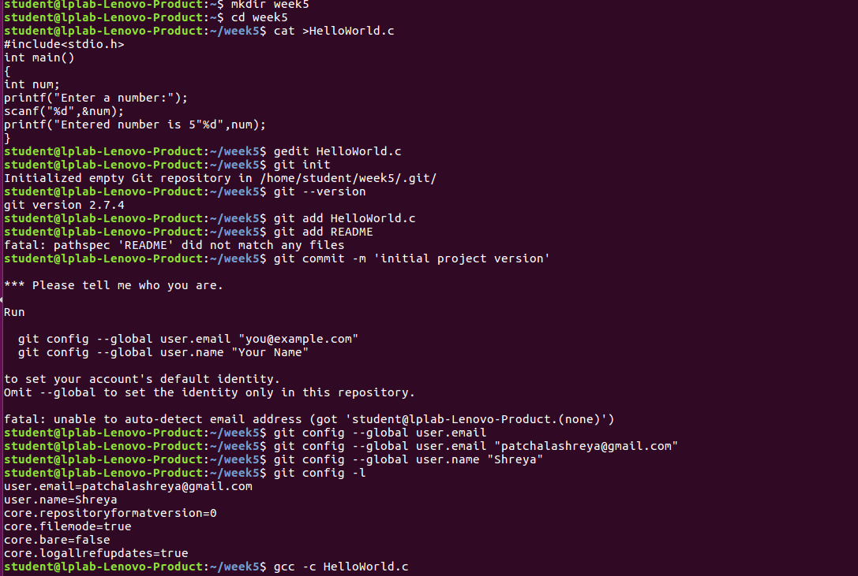
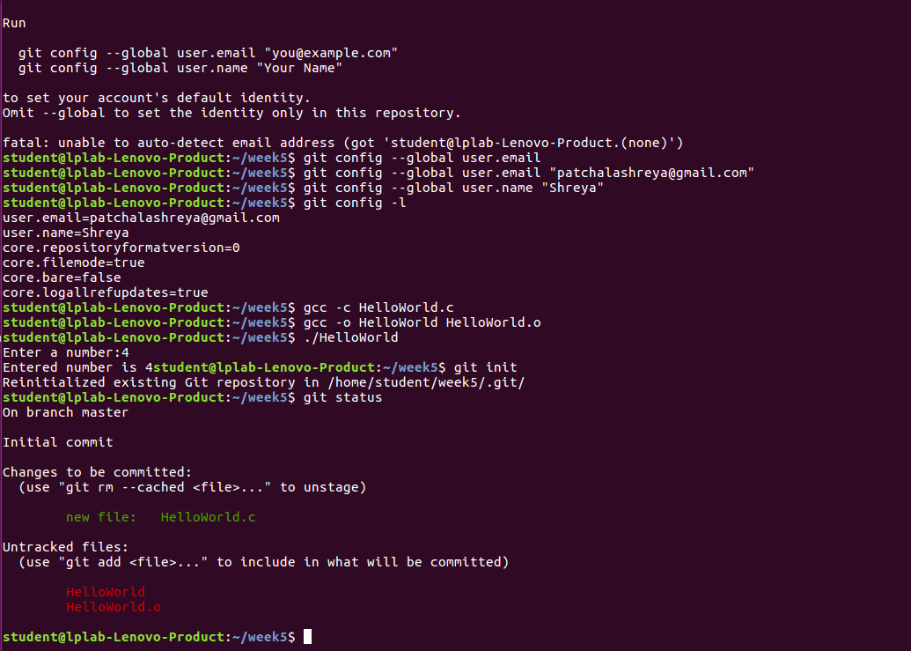

Q2.

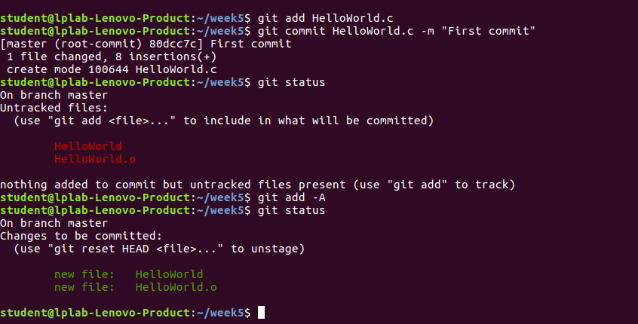

Q3.

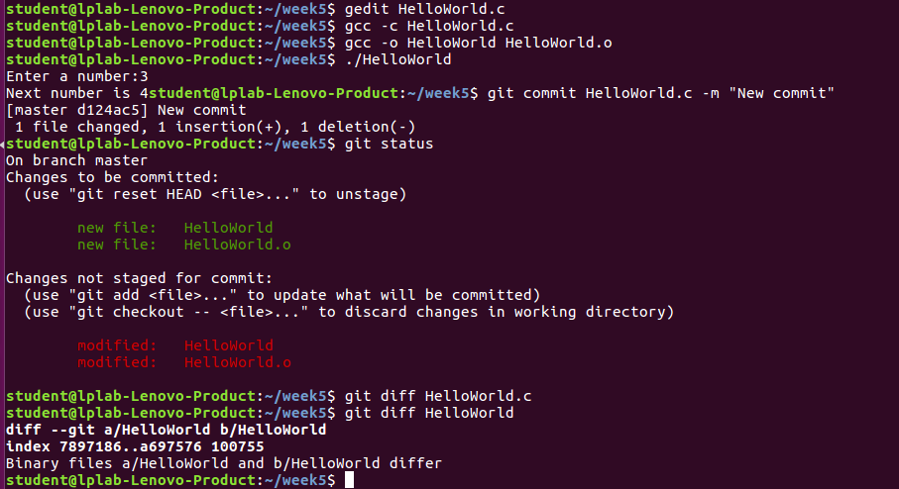

Q4.

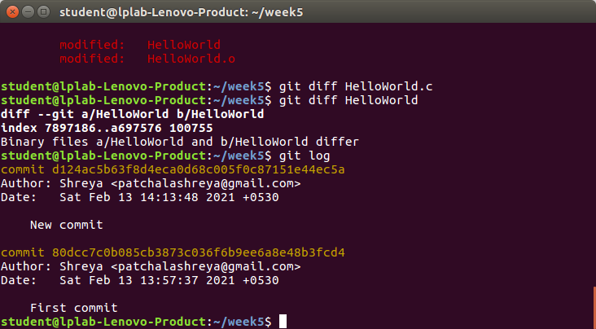

Q5.

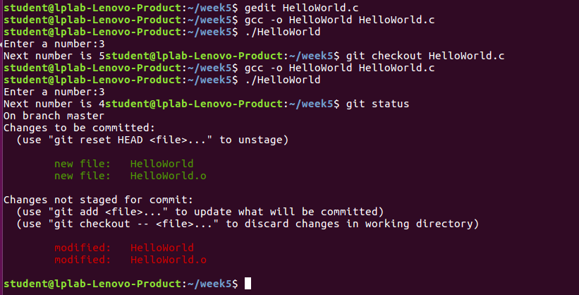

Q6.

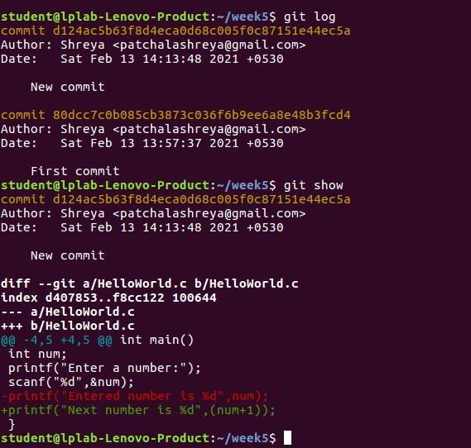

GDB PROGRAM:

student@lplab-Lenovo-Product:~/190905067_OSTL/Week5$ gedit HelloWorld.c
student@lplab-Lenovo-Product:~/190905067_OSTL/Week5$ gcc -g -o HelloWorld HelloWorld.c
student@lplab-Lenovo-Product:~/190905067_OSTL/Week5$ gdb HelloWorld
GNU gdb (Ubuntu 7.11.1-0ubuntu1~16.5) 7.11.1
Copyright (C) 2016 Free Software Foundation, Inc.
License GPLv3+: GNU GPL version 3 or later <http://gnu.org/licenses/gpl.html>
This is free software: you are free to change and redistribute it.
There is NO WARRANTY, to the extent permitted by law. Type "show copying"
and "show warranty" for details.
This GDB was configured as "x86_64-linux-gnu".
Type "show configuration" for configuration details.
For bug reporting instructions, please see:
<http://www.gnu.org/software/gdb/bugs/>.
Find the GDB manual and other documentation resources online at:
<http://www.gnu.org/software/gdb/documentation/>.
For help, type "help".
Type "apropos word" to search for commands related to "word"...
Reading symbols from HelloWorld...done.
(gdb) break main
Breakpoint 1 at 0x40064e: file HelloWorld.c, line 3.
(gdb) run
Starting program: /home/student/190905067_OSTL/Week5/HelloWorld

Breakpoint 1, main () at HelloWorld.c:3
3 {
(gdb) next
5 printf("Enter a number- \n");
(gdb) next
Enter a number-
6 scanf("%d",&num);
(gdb) next
5
7 int n = num+0;
(gdb) list
2 int main()
3 {
4 int num;
5 printf("Enter a number- \n");
6 scanf("%d",&num);
7 int n = num+0;
8 printf("Next number is- %d",n);
9 }
(gdb) next
8 printf("Next number is- %d",n);
(gdb) print num
$1 = 5
(gdb) next
9 }
(gdb) print n
$2 = 5
(gdb) break HelloWorld.c:7
Breakpoint 2 at 0x40067d: file HelloWorld.c, line 7.
(gdb) next
__libc_start_main (main=0x400646 <main>, argc=1, argv=0x7fffffffde38,
init=<optimized out>, fini=<optimized out>, rtld_fini=<optimized out>,
stack_end=0x7fffffffde28) at ../csu/libc-start.c:325
325 ../csu/libc-start.c: No such file or directory.
(gdb) print n
No symbol "n" in current context.
(gdb) next
Next number is- 5[Inferior 1 (process 5224) exited normally]
(gdb) info locals
No frame selected.
(gdb) n
The program is not being run.
(gdb) run
Starting program: /home/student/190905067_OSTL/Week5/HelloWorld

Breakpoint 1, main () at HelloWorld.c:3
3 {
(gdb) break HelloWorld.c:7
Note: breakpoint 2 also set at pc 0x40067d.
Breakpoint 3 at 0x40067d: file HelloWorld.c, line 7.
(gdb) print n
$3 = 32767
(gdb) info locals
num = -8656
n = 32767
(gdb) n
5 printf("Enter a number- \n");
(gdb) n
Enter a number-
6 scanf("%d",&num);
(gdb) n
6

Breakpoint 2, main () at HelloWorld.c:7
7 int n = num+0;
(gdb) n
8 printf("Next number is- %d",n);
(gdb) info locals
num = 6
n = 6
(gdb) n
9 }
(gdb) n
__libc_start_main (main=0x400646 <main>, argc=1, argv=0x7fffffffde38,
init=<optimized out>, fini=<optimized out>, rtld_fini=<optimized out>,
stack_end=0x7fffffffde28) at ../csu/libc-start.c:325
325 ../csu/libc-start.c: No such file or directory.
(gdb) n
Next number is- 6[Inferior 1 (process 5272) exited normally]
(gdb) n
The program is not being run.
(gdb) quit
